2D Array Katas

## **PART I**

## Define arrays two ways:

**var board = new Array(8); // don’t need push**

**var board = []; // need array.push to populate**

## Code

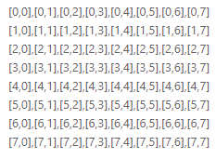

Create a Chessboard // add whole rows (5 lines)

**var rows = 8, columns = 8;**

**var board = new Array(rows);**

**for (i = 0; i < rows; i++) {**

**board[i] = new Array(columns);**

**}**

Populate the Chessboard with Cell Addresses (add 6 more lines)

**for (i = 0; i < rows; i++) {**

**for (j = 0; j < columns; j++) {**

**board[i][j]="["+i+","+j+"]";**

**}**

**}**

**alert(board.join('\n'));**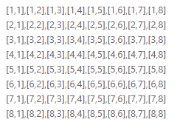

## Tasks

1. Using array.splice() and tweaks, change the board so it looks like this -- no zeros: (add 2 more lines)

## **PART II**

## Alert Arrays Two Ways:

1. array.join() // above
2. var alertString = alertString.concat(board[row].slice(0, 9).join(" "));

## Code

**var rows = 8, columns = 8;**

**var board = new Array(rows);**

**for (i = 0; i < rows; i++) {**

**board[i] = new Array(columns+1);**

**}**

**for (i = 0; i < rows; i++) {**

**for (j = 0; j < columns; j++) {**

**if (i%2==0&&j%2==0) {**

**board[i][j]=" * ";**

**}**

**else if (i%2!=0&&j%2!=0) {**

**board[i][j]=" * ";**

**}**

**else board[i][j]=" ";**

**}**

**}**

**var alertString="";**

**for (var row=0;row<rows;row++) {**

**alertString = alertString.concat(board[row].slice(0,8).join(" "));**

**alertString = alertString.concat("\n");**

**}**

**alertString = alertString.concat("");**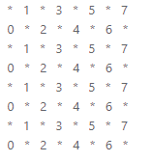

**alert(alertString); // testing purposes**

## Tasks

1. Change it to add numbers: (change 1 line)
2. Change it to look like Tic Tac Toe below (26 lines total):  
     
     
   